<http://www.food-info.net/uk/e/e420.htm>

Celine Chang:

Whole Grain Rolled oats - Taste/structure, improves solidity

Crisp Rice

Rice flour --texture (can make baked goods seem unique and sandy) and flavor (make energy bar extra tender and crumbly, with a melt-in-your-mouth feeling)

Sugar-- nutrition (carbohydrates), preservation (When sugar is added to foods it binds to the water in the foods reducing the amount of water that is available for the growth of microorganisms) flavor, texture

Malt -- Texture

Malted barley and corn extract--Texture (to give a glossy surface and a soft, fine crumb),

Wheat starch -- lowers viscosity

Hydroxylated soy lecithin -- Texture (used to soften chocolate)

Salt -- preservative, improves taste recognized from other ingredients

Sugar -- increases sweet taste

Tony Hoch

Whole grain rolled wheat - Taste/structure, improves solidity

Invert sugar -- Texture (smoother than regular sugar, similar to a syrup - holds other ingredients together)

Corn syrup solids -- Flavor (sweetness), Texture (moisture), prevent crystallization of sugar

Nonfat dry milk -- nutritional value (dairy), the use of dried milk lengthens shelf life

Glycerin--texture, flavor (food grade glycerin can be added in food as a wetting agent, thickener, solvent or sweetener)

Water -- see notes from class

Honey--Flavor, Nutrition (contain micro-nutrients (vitamin & essential minerals) and macro-nutrients (carbohydrates & amino acids) )

Yogurt flavored coating

Sugar--Nutrition,Flavor

Vegetable oil

Palm kernel and palm oil--Preservation(palm oil resists oxidation under high cooking temperatures and upon storage),Nutrition (cholesterol-free and contain vitamin k)

Whey protein concentrate--nutrition (protein) , texture (aeration properties, water and fat binding properties, and ability to form gel)

Cultured nonfat milk -- nutrition (protein/dairy), preservation (culture improves shelf life), taste

Soy lecithin -- softens chocolate, stabilizes water and oils

Natural flavor - taste

**Titanium dioxide** - color

**Citric acid** - flavor, texture, preservation

Salt - preservation, enhances flavor

Sunflower oil - preservation (prevents rancidity of animal oils)

Sorbitol - texture, preservation, taste (sweetens with few calories)

Salt - preservation

Soy lecithin - preservation due to emulsification properties, texture due to softening

Tocopherols (preservative) - preservation due to emulsification properties and nutrition ( many of tocopherols have vitamin E activity)

FDA Label for improved product

Sugar substituted for coconut sugar

Flour to almond flour

Agave nectar for high fructose corn syrup

FDA Label for original product

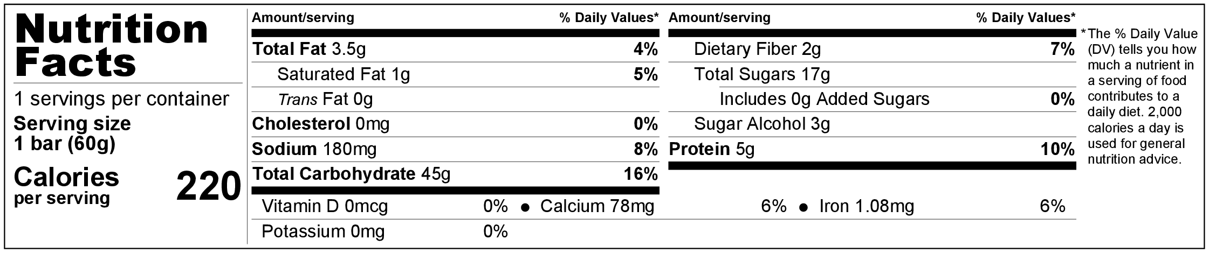

FDA Label for New Product

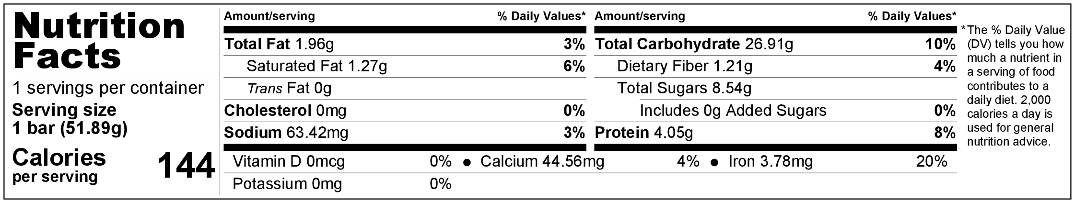

If we look directly at the data, total fat, sodium, total carbohydrate, fiber, sugar, and protein

First of all, the serving size has decreased. The improved bar is now 51.89g instead of 60g, which is 86.483% of the original version. Thus, the nutrient values cannot be directly compared. If the ne

5. Explain how your changes have improved the bar’s nutrition

FDA daily value based on 2000 calories diet:

Total fat: 65 g

Saturated: 20g

Cholesterol: 300 mg

Sodium: 2400 mg

Total Carbohydrate: 300 g

Dietary Fiber: 25 g

Protein: 50 g

Vitamin D: 400 IU

Potassium: 3500 mg

Calcium: 1000 mg

Iron: 18 mg

6. Explain the differences between your bar and the improved version.

The changes we made reduced the weight of the bar bar by less than 14% and impressively reduced the caloric content by 35%. We substituted **KATIE PUT THE SUBSTITUTES HERE PLEASE.** At first, the new bar does not appear to be of greater nutritional value than the original bar, but upon further inspection it proves to provide the body with a greater nutritional value/weight ratio. The daily percentages of sodium and carbohydrates were greatly decreased whereas the percentage of protein was only slightly decreased. This is important because daily percentages of sodium and carbohydrates are often met by consumers while protein is not.